## Thermal Analysis

In this part thermal analysis of the main switching devices, two paralleled MOSFETs and the output diode, are discussed. For all switching devices OZDAS0003EPL25 aluminum heatsink given in Figure … is used.

Figure 1 OZDAS0003EPL25 Aluminum Heatsink

All main switching devices show the same thermal lumped parameter circuit behavior given in Figure …

Figure 2 Thermal Lumped Parameter Circuit

The junction temperature of the semiconductor devices can be written as follows:

$$Tjunction=Tambient+Ploss (RJC+RCH+RHA)$$

Thermal resistance from heatsink to ambient temperature is 7.5 °C/W for OZDAS0003EPL25 aluminum heatsink. The ambient temperature is taken as 30 °C since the demo is conducted in summer. Junction to case and case to heatsink thermal resistances, maximum power loss on the semiconductor devices observed in the simulation and settling junction temperature according to the formula given above are tabulated in Table …

|  |  |  |  |  |
| --- | --- | --- | --- | --- |
| **Switching Device** | **RJC (°C/W)** | **RJC (°C/W)** | **Ploss (W)** | **TJ (°C)** |
| MOSFET | 1.05 | 0.5 | 1.52 | 44 |
| DIODE | 1.7 | 0.5 | 3.13 | 61 |

Table 1 Thermal Analysis According to Simulations

Although these results do not require any type of cooling system, in real testing MOSFET temperature is observed to exceed 100 °C. Next, oscilloscope probes are utilized to measure switch current and voltage. The power loss on the MOSFET measured as 7.5 Watts by the MATH and mean functions of the oscilloscopes as mentioned in Test Results Section. According to this measurement and lumped parameter approach MOSFET junction temperature is calculated as 96 °C which is unacceptable. Therefore, a fan is used to cool down the switching devices. In the last design MOSFET operates at 63.6 °C which is shown in Figure …

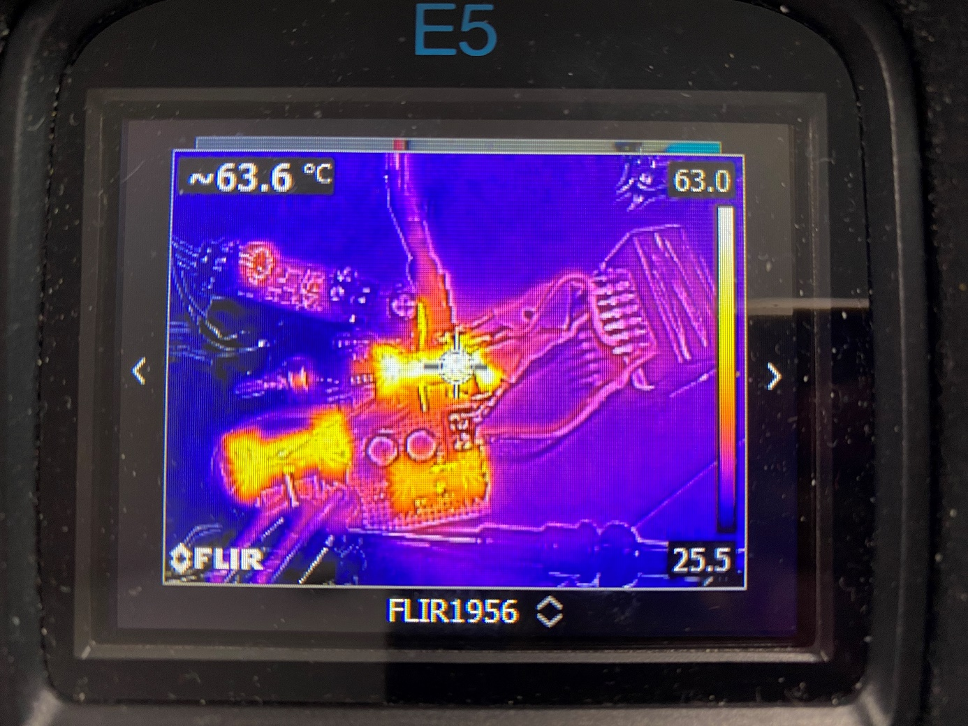

Figure 3 Thermal Photograph of the Converter